*Florida International University*

*School of Computing and Information Sciences*

Software Engineering Focus

Feature Document

User Story ID 697

**Name:** Assign devices to sub-user

**Team Member(s):** Leandro Gonzalez,Luis Herrnsdorf

**Project:** Smart Stormwater (Smart City System) 2.0

**Product Owner(s)**: Emilio Lopez

**Mentor(s)**:

**Instructor**: Masoud Sadjadi

**User Story Name:** Assign Devices to Sub-user

* Description: As an admin, I want to be able to assign a device to a sub-user so that he/she can be in charge of the device

Acceptance Criteria

* Clicking on a user on the sub-users page will highlight the selected user.
* A table on the bottom of the screen will display the devices assigned to the selected sub-user
* A plus button on the top right corner of the devices table allows assigning devices to the selected sub-user
* Clicking the plus button opens a floating window displaying the devices assigned to the logged in user
* User can multi-select devices and click on assign, thus assigning the selected devices to the selected user, or click cancel and cancel the operation
* Upon assigning the device, the changes will be reflected on the device table of the sub-users page

**Use Case**

* Name: Assign device to sub-user
* Actor: Admin
* Preconditions: Admin is logged in, admin has devices assigned
* Description: On the main page, the admin clicks on the ‘Users’ tab on the side panel. On the ‘Users List’ table, the admin selects a user by clicking on it. A ‘Devices per User’ table on the bottom of the screen shows all the devices assigned to the selected user. The admin clicks on a plus button on the top right corner of the ‘Users List’ table. A floating windows comes up, showing all devices assigned to the admin. Admin multi selects devices and clicks on ‘Assign’. The floating windows closes after the selected devices are assigned to the selected user.

**Use Case Diagram**



**Sequence Diagram**

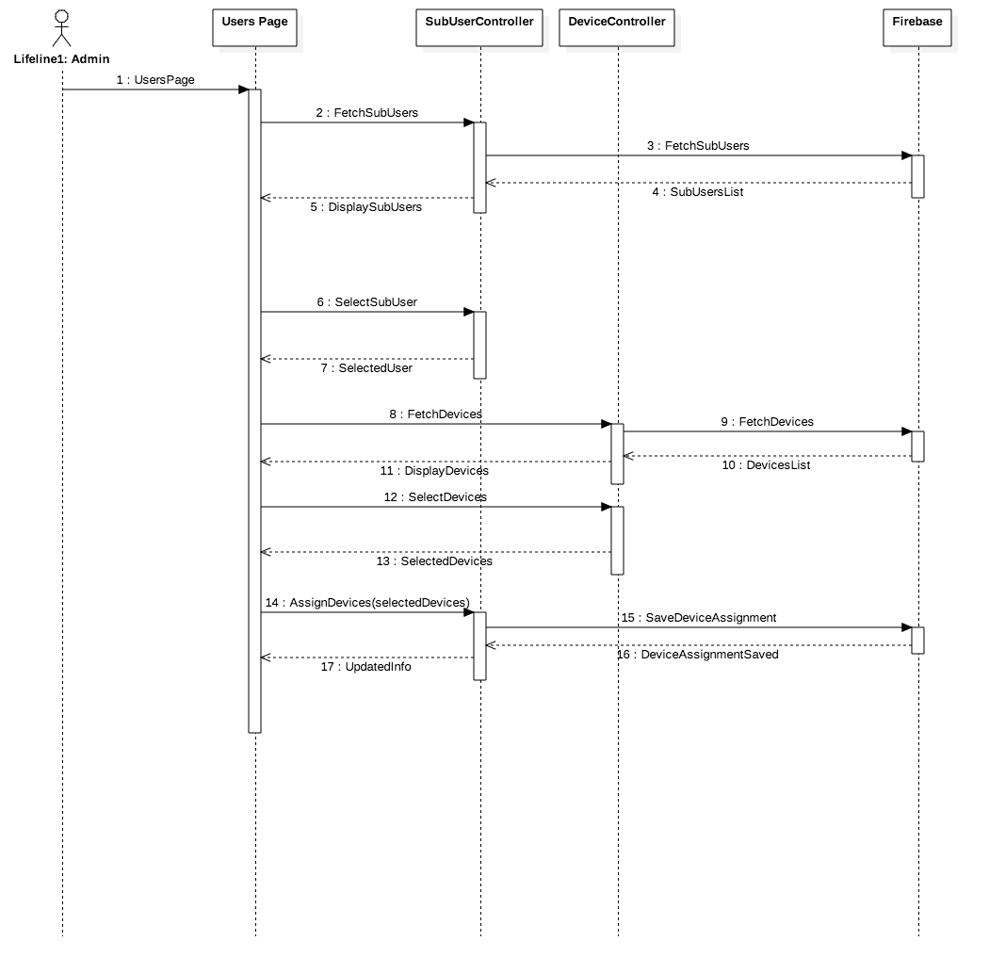

**Class Diagram**

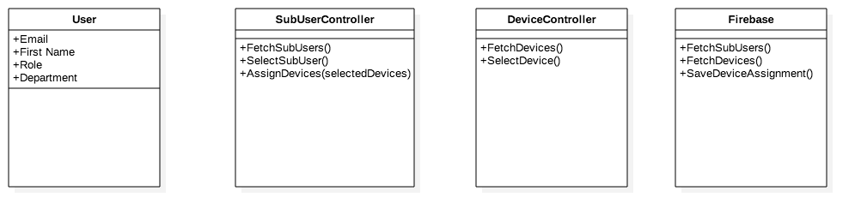

**Unit Test**

* Test case ID: AssignDevice001
* Description/Summary of Test: Admin assigns devices to a sub-user
* Pre-condition: Admin is logged in, a user is selected in the ‘Users List’ table of the Users page
* Expected Results: Selected devices are assigned to the selected user
* Actual Result: The selected devices were assigned to the selected user
* Status (Fail/Pass): Pass

**Visual User Guide** 